**San Francisco Bay University**

**CS483 - Fundamentals of Artificial Intelligence**

**2022 Summer Final Exam**

**Student Name: Student ID:**

**Instruction**

1. **Put your answer right after each question in the answer sheet**
2. **Make a copy & paste of your program in text mode, NOT image onto the answer sheet.**
3. **Excel is preferred for hand calculation**
4. The following decision tree is built up from one of animal classification datasets. Please calculate information gains based on gini impurity from top to **each** leaf

1. Chromosome crossover operation is one of the processes for generation evolution in Genetic Algorithm. Write the Python function(s) with "Crossover Rate" parameter to implement it, taking the following parent chromosomes as test case in your program.

|  |  |
| --- | --- |
| Parents | New Gen. for example |
| 1101111001 | **1101111011** |
| 1100001011 | **1100001001** |
| 1100001011 | **1100001011** |
| 1110010000 | **1110010000** |
| 1101111001 | **1110010000** |
| 1110010000 | **1101111001** |
| 1110100001 | **1110100001** |
| 0011010000 | **0011010000** |
| 1101111001 | **1101111000** |
| 0100110010 | **0100110011** |
| 1001011010 | **1101111001** |
| 1101111001 | **1001011010** |
| 0111011111 | **0111010101** |
| 1001110101 | **1001111111** |
| 1101111001 | **1101111001** |
| 1110100001 | **1110100001** |

1. Being similar as above, write the Python function(s) with "Mutation Rate" parameter to implement mutation operation for the given chromosome as test case.

|  |
| --- |
| New Gen. |
| 1001011010 |
| 1110010000 |
| 0111010100 |
| 1110010101 |
| 0111010000 |
| 1110010101 |
| 1110100011 |
| 1110100001 |
| 0100111000 |
| 0110010011 |
| 1110001011 |
| 1000010010 |
| 0001011010 |
| 1011010000 |
| 1101101001 |
| 1110010000 |

1. Assuming that a salesperson who has to travel between the following three cities for his/her job - London, Barcelona, and New York, his/her goal is to minimize the traveling time so that he/she can be more efficient. A set of transition probabilities among three cities is given as follows and initial probabilities where he/she is as well. The salesperson starts his/her journey on Tuesday from a city and he/she has to plan something on Friday. Please calculate what is the probability that he/she will be in three cities on Friday by Python program?

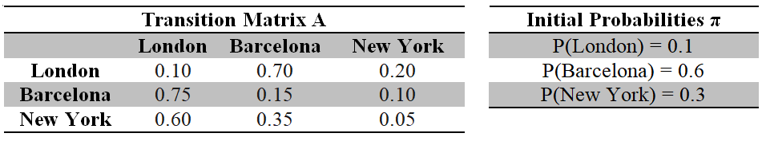

*\*Hint: In the Markov chain, after 3 days from Tuesday, transition matrix A will be becoming $A^{3}$ from the state "Tuesday" to the state "Friday". And the probabilities in three cities - London, Barcelona and New York on Friday should be equal to π $A^{3}$*, and the size of π is 1*×*3 matrix, like*

*[P(London), P(Barcelona), P(New York)]*